1. HDFS TO LOCAL

TEXT FILE IN LOCAL FILE SYSTEM

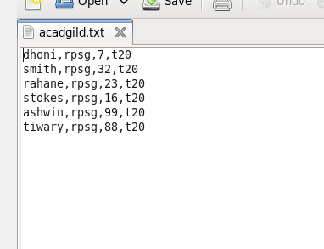

LOADING IN HDFS

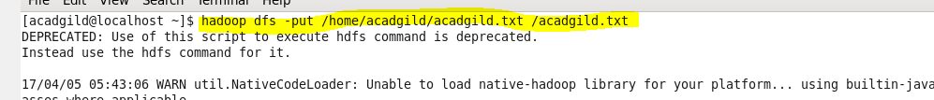

JAVA API TO CREATE JAR FILE

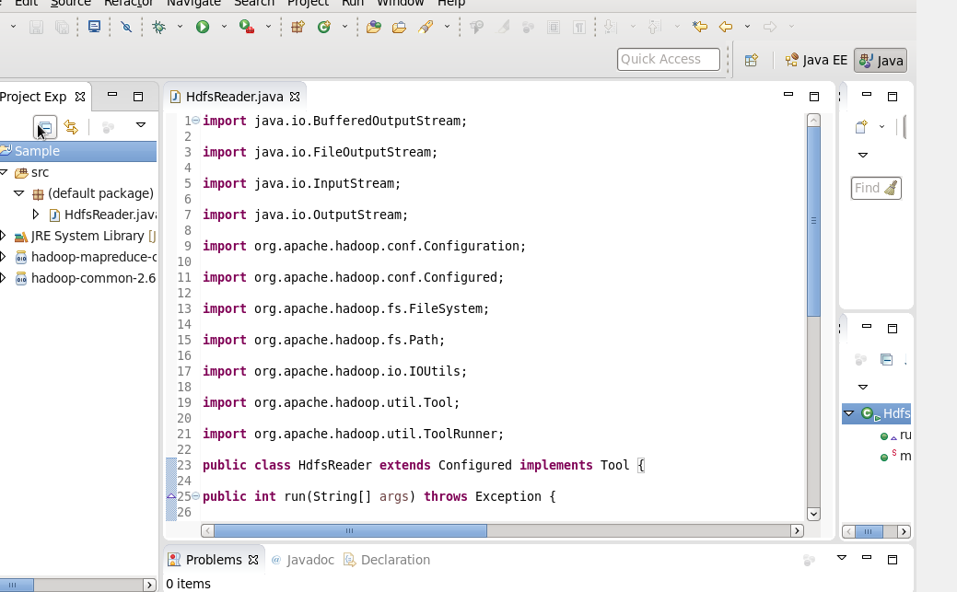

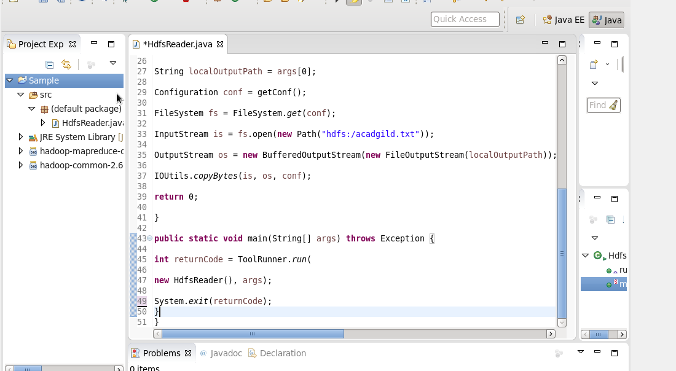

EXECUTING JAR FILE

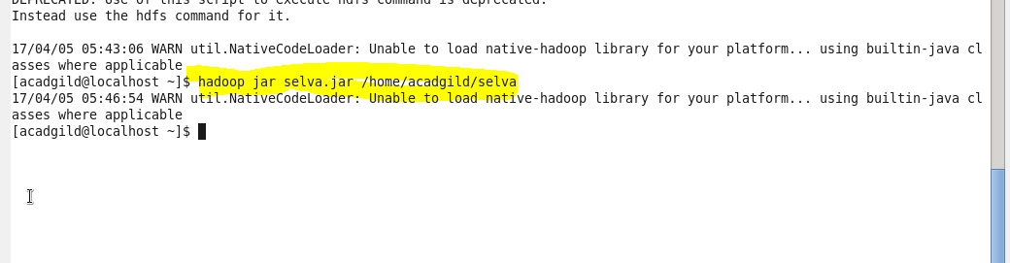

AFTER EXECUTION FILE SELVA IS CREATED IN LOCAL FILE SYSTEM

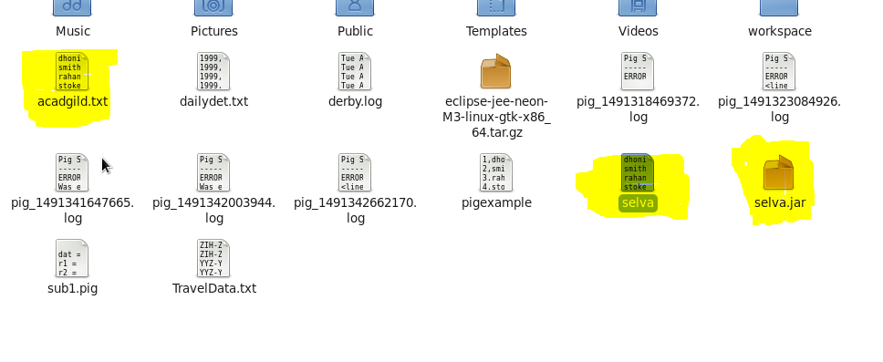

SHOWING CONTENTS IN LOCAL FILE SYSTEM

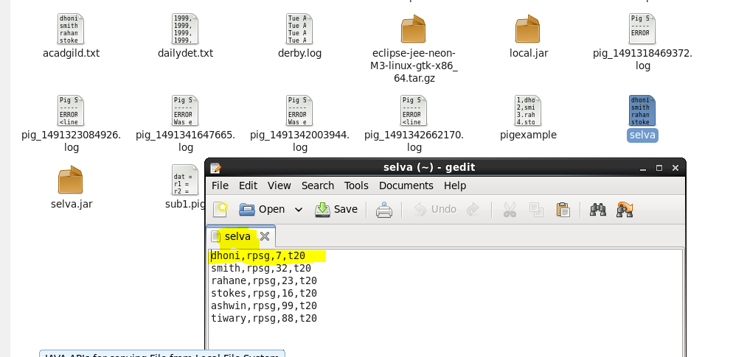

2. LOCAL FILE SYSTEM TO HDFS

FILE IN LOCAL FILE SYSTEM

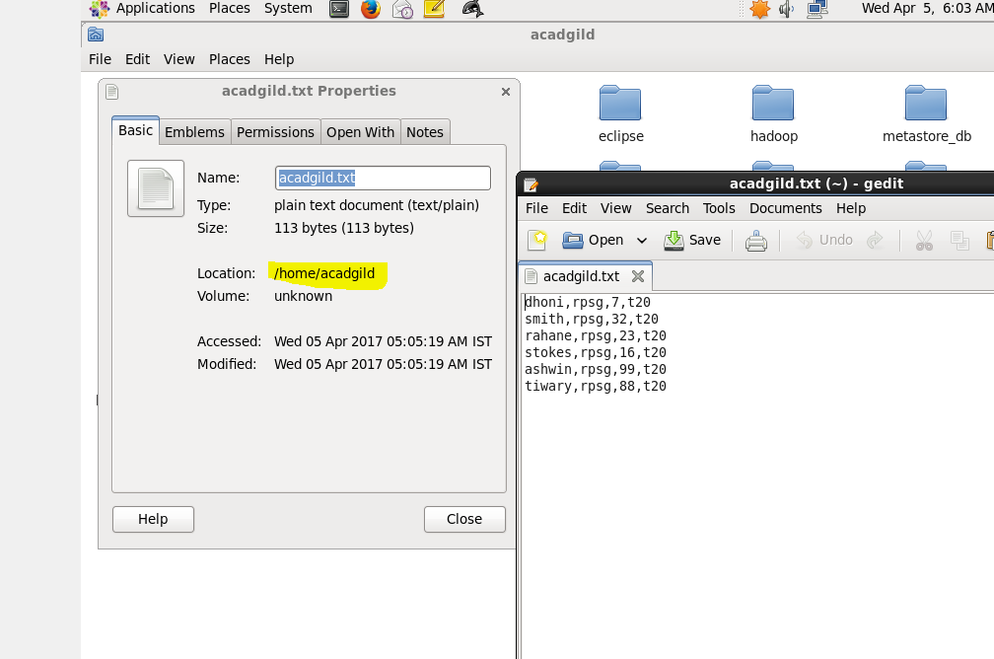

JAVA API FOR LCAL FILE SYSTEM TO HDFS

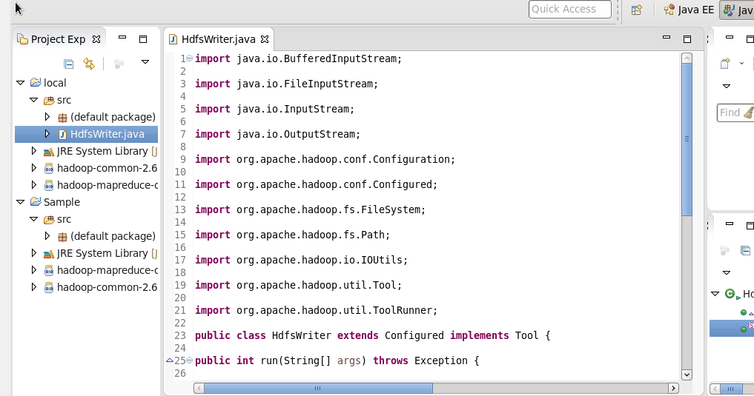

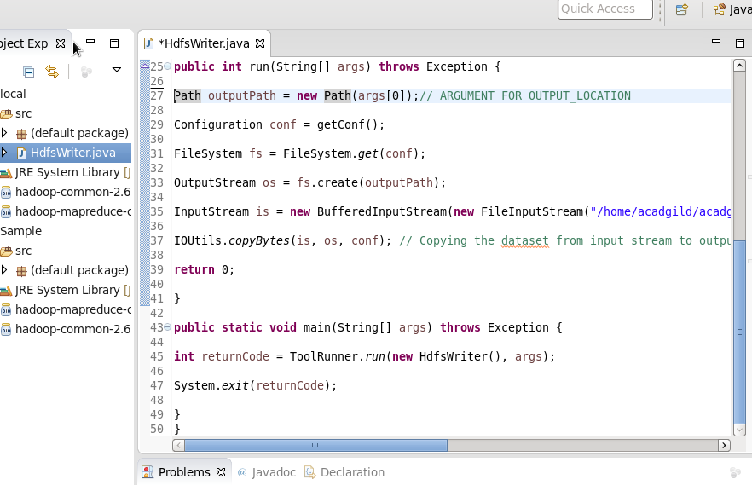

EXECUTING JAR AND LOADING IN HDFS

AND LISTING USING -ls

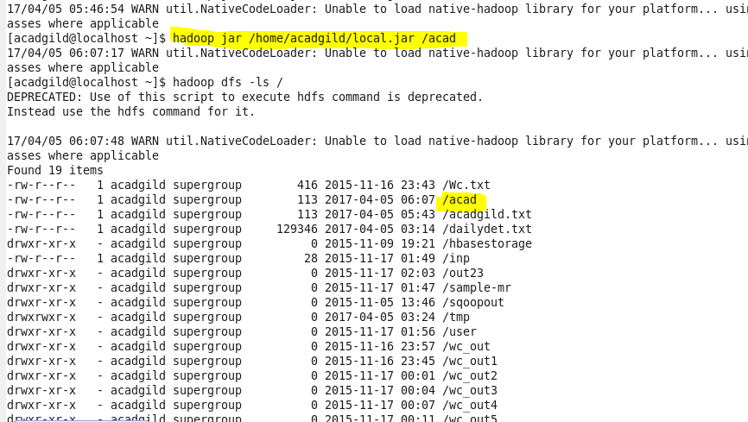

SHOWING CONTENTS USING -CAT COMMAND

